Lab 8 Report

Preface

Still waiting on accelerometer part. Most of this week has been focused on revising my PCB errors and just doing simple tests with the H-Bridge, BLE-BLE communication between Arduino and the HC-08 connected to the LaunchPad, and Figuring out UART and ADC setups so that they do not conflict. Working solo on all labs still. No modifications to SCH file but did change PCB layouts for UTX-205 board, which is uploaded along with this report.

Lab 8 Goals

• Collect and test all hardware components for the project,

• Write low-level software for each I/O interface,

• Validate that overall project is possible, and update the requirements

document.

• Review data sheets for your microcontroller, and your hardware components

Requirements Document (taken from Lab 7, no changes made in Lab 8 testing)

**1. Overview**

**1.1. Objectives:** The purpose of this project is to design an embedded system and study the topics of power, ADC, DAC, interrupts, UART, displays, and programming for the embedded system. Understanding PCB design and how the components interact with each other in the embedded system are integral to the completion of the lab.

**1.2. Roles and Responsibilities:** The clients are the TA and the Professor. I (the student) will be designing the PCB and programming for this lab.

**1.3. Interactions with Existing Systems:** There will be GPIO analog sensor readings, digital outputs, and power interactions between the PCB and the LaunchPad. Data transfer will occur between the LaunchPad and a wearable device with a NodeMCU using an HC-08 BLE module with UART.

**2. Function Description**

**2.1. Functionality:** The system will consist of a motorized vehicle that can operate autonomously to follow a person or be controlled directly from a wearable device using Bluetooth communication. IR receivers will allow the robot to track a beacon worn by the individual and an accelerometer or flex resistors embedded in the wearable device will enable remote control over the system. LCD displays will relay information to the user about the mode the robot is in, IR sensor data, motors/gears in use, and the inputs it is receiving from the controller.

**2.4. Performance:** Once the final design is assembled, power measurements will be determined based on the current draw of the system using either a power supply or a voltmeter. For initial current approximations, datasheet information will be used and the current draw of each individual component under load will be measured. Performance will be based on how accurately the robot can follow the user and its responsiveness to commands sent via the wearable system.

**2.5. Usability:**

Human interfaces will include the following:

- ST7735R LCD on robot will output visualizations of the sensor data such as IR distance readings, accelerometer data, motor power output. LaunchPad will connect to ST7735R display

- SSD1306 OLED 128x32 pixels on wearable will show basic information (robot mode, commands to send to robot, ect.). This will be connected using SDA and SCL lines to the NodeMCU

- Momentary buttons on both robot and wearable to access different software functions, display information and levels of control

Other interfaces between main components will include the following:

- UART between the HC-08 BLE module and the LaunchPad (115200 baud rate)

-Bluetooth between HC-08 BLE module and Arduino Node MCU on wearable device

- L293NE H-bridge for drive motor control using LaunchPad GPIO pins, L293NE allows for forward, reverse, coasting, and braking

- 711 DC motor for forward and reverse drive controlled through L293NE

- HiTEC HS-422 servo controlled by LaunchPad PWM GPIO pins to steer wheels

- IR detector and LaunchPad GPIO pins for analog readings

- Raw data sent between 6-axis gyro/accelerator to the NodeMCU, which is in turn sent in the raw form to the LaunchPad for processing (do as much on the LaunchPad as possible since it is used for the class)

**3. Lab 8 Completion and Deliverables**

Preparation (do this before your lab period)

Part a) Four or more identifiable subcomponents such that each student is responsible for at least one subcomponent (including but not limited to sensors, actuators, wifi, BLE, enclosure, power, user interface) TAs will judge if the project is sufficiently complicated. If subcomponent breakdown is required as preparation to Lab 8.

Part b) You must have all resistors, capacitors, chips, connectors, and components for the project. If your project uses a LaunchPad, then you will plug your LaunchPad onto the PCB. At this point, you should have all parts needed to build the system.

Part c) If necessary, show on your circuit diagram (SCH file) how this Lab 8 test prototype will be different from the final system. For example, your final product might run on a single-chip TM4C123, but you will test it with the LaunchPad.

Part d) Write all the header files (prototypes for public functions) for your entire system. The most efficient process is to have designed, implemented and typed all software as part of the preparation. In this way, you can build the circuits and debug while the TA is present.

Procedure (do this during your lab period)

Part a) Please procure or build the box for the project. We recommend you build your box in the makerspace. See

http://users.ece.utexas.edu/%7Evalvano/HowToDesignEnclosureMakerspace.htm

Part b) Running on the prototype system, debug the hardware and software in a modular fashion. You should write and test all software that directly interacts with the hardware. You do not need to have the high-level software written, but all low-level device driver software should be written and tested in Lab 8.

If you need to reprogram the ESP8266, please see your TA about which application to use and how to reprogram it.

Part c) The requirements document is fluid, meaning it is expected to change during product development. You may find your system will have higher or lower performance than originally conceived. You may also need to modify what it will do. Rewrite your requirements document to reflect what you now think is realistic for your system.

Part d) Collect preliminary performance data as appropriate. This step is especially important if your device has transducers.

Deliverables (exact components of the lab report)

A) Objectives

1-page requirements document (Procedure c)

B) Hardware Design

Modified circuit diagram (SCH file), as tested in Lab 8

C) Software Design

Include the low-level I/O drivers (Preparation d, Procedure b)

D) Measurement Data

Give any performance data you collected (Procedure d)

E) Analysis and Discussion (none)

Checkout (show this to the TA)

Show the hardware/software prototype of your system to your TA. Explain how the prototype is different from the final product. Discuss the testing features of your design. Discuss your top three worries about finishing Lab 11 on time.

Below is a picture of some of the main components/interfaces that will possibly be used:

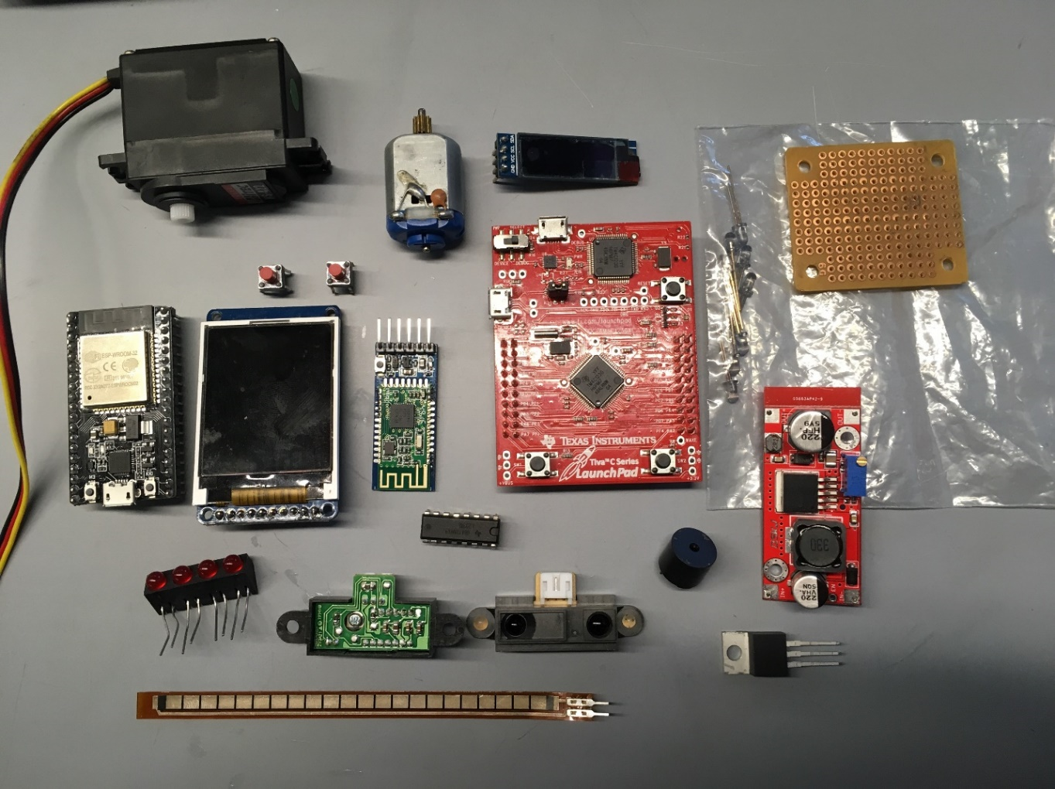

Testing of the Lab8 Software was completed using motors and gearboxes on an old EE302 line follower robot that uses the same motors chosen in Lab7, seen below:

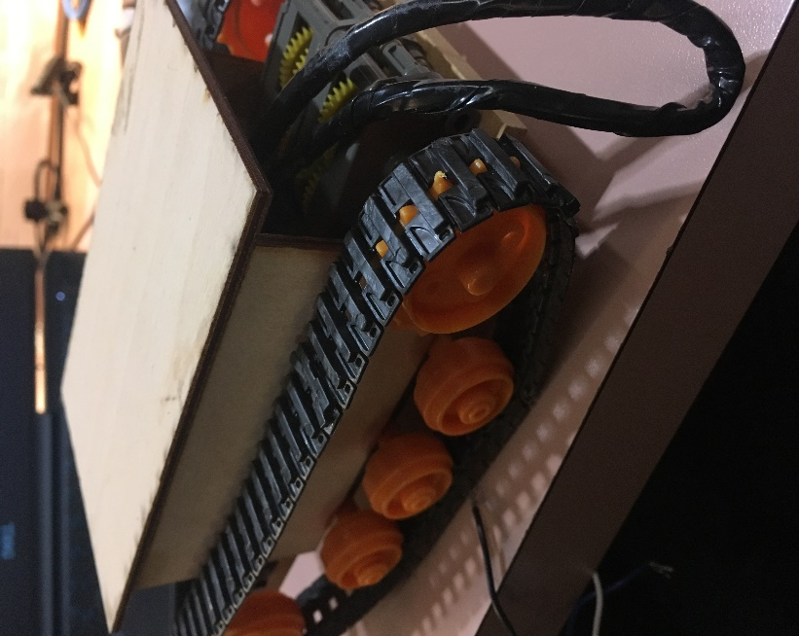

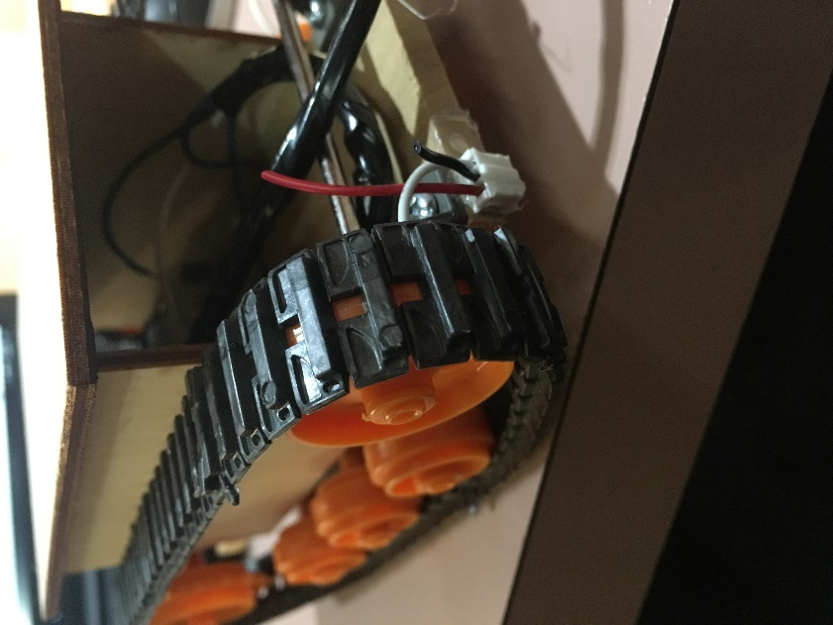

Measurements

New for Lab 8:

Measurements taken for Lab 8 include single motor current powered using 9V from a battery through an L293NE H-bridge IC. The current for a single motor under the weight of the robot using a gearbox was measured to be 1.17 Amps using a multimeter. Analog IR receiver values were calculated by holding an IR diode and moving it across the face of the IR receiver from edge to center. The ADC value recorded for the IR light incident on the receiver at an angle that required the robot to turn/course correct to one side for example was found to be around 1200 or less. If the ADC value exceeded 2950 then the robot needed to course correct to the other side. Anything in between those values meant that between the two IR receivers, the IR source was dead center between the two (not too close to one side or the other).

Recap from Lab 7 (old but useful information for Lab11):

Total cost to produce the system (cost of all components minus ones provided by class/lab) is approximately $59.06 at current market prices. I currently own all of the required parts, so there is no wait time or shipping costs associated with starting the manufacturing process of the embedded system. See Lab 7 BOM for complete details.

For the vehicle system, the peak current draw based on individual component values under load is approximately:

* 80mA for the LaunchPad
* 35mA for the HC-08
* 55mA for the ST7735R
* 250mA-300mA for the HS-422 servo (high load)
* 1.6A for the 711 brushless DC motor at max
* 15mA x 4 SHARP QH3031 IR Receivers
* 47mA for worst case logic and output levels for the L293NE H-bridge

Thus, the total approximate current draw for the vehicle system alone is 2.177 A at full load. To last close to one hour under full load at the class Expo, a 5000mAh battery would be required.

The peak current values for components used in the wearable device is approximately:

* 67mA for the NodeMCU with BLE microcontroller
* 20mA for the SSD1306 OLED
* 18mA x 2 IR diodes as a beacon for robot to follow
* 15mA for the accelerometer

The total approximate current draw is 138mA for the wearable system. To last the duration of the class Expo, a 250mAh battery would suffice.